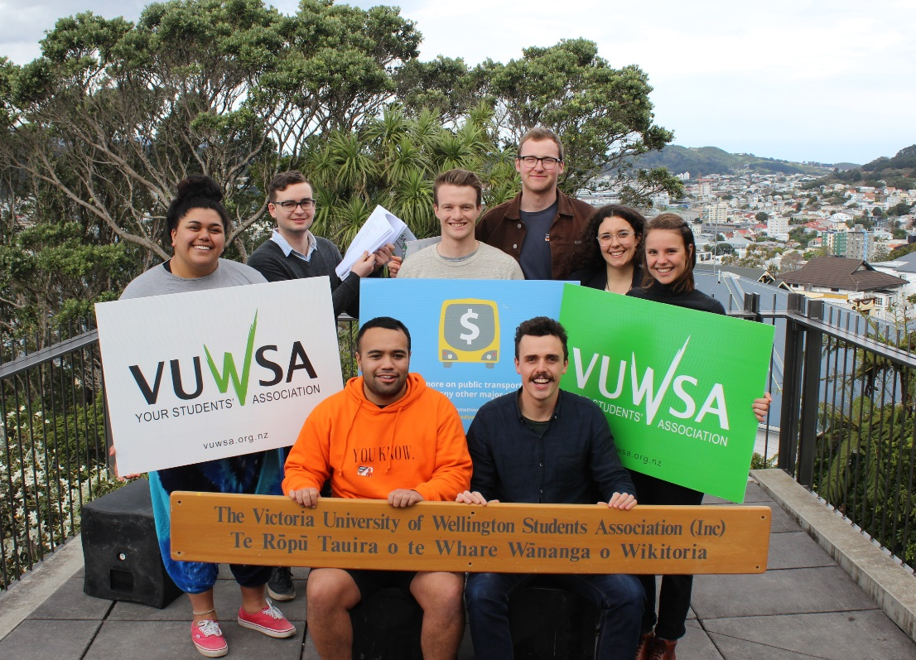
VUWSA Submission to the GWRC Long Term Plan
Regarding the introduction of a reduced tertiary fare on public transport.
Authorised by Rory Lenihan-Ikin (VUWSA-VUW Students Assn)

TO | Greater Wellington Regional Council
FROM | Victoria University of Wellington Students’ Association (VUWSA)
DATE | September 18th 2017
SUBJECT | Submission on the GWRC Long Term Plan

- Introduction
- Summary of Recommendations
- Re-cap of the case for Fairer Fares
- What do we think of the plan?
- Extending the proposed tertiary concession to all tertiary students
- Other recommendations
- Contact

1. Introduction
Victoria University of Wellington Students’ Association (VUWSA) functions to represent and advocate for the interests of Victoria University of Wellington students.
It is a democratic organisation; run by students for students. We are committed to fair representation and work tirelessly to consult with our members on issues of campus, city and national importance.
VUWSA has spent years putting our case to the Greater Wellington Regional Council (GWRC) about the need for a tertiary student discount on public transport. We are very happy that the GWRC has decided to include a 25% reduced tertiary fare in the long term plan for the first time ever. This proposed change will help make tertiary education more accessible for many students. However, VUWSA has identified some issues with the proposed tertiary concessions and recommends the changes outlined below, to make this change truly equitable and fair for all Wellington students.

2. Summary of Recommendations
- That the GWRC includes a 25% discounted tertiary concession on all public transport in the greater Wellington region and that this tertiary concession be made available to all tertiary students, including those studying part-time.
- That the GWRC set the accessibility fare at the same rate as the child fare to reflect mobility barriers faced by people with disabilities.
- That GWRC fast track/find an interim solution to enable Snapper (or other smart card) on trains.

3. Re-cap of the Case for Fairer Fares
Years of campaigning and conversation with Councillors, council officers, ratepayers and students from all across the region have left us in no doubt that targeted tertiary concessions are an extremely effective way to make a big difference for our regional community, by making tertiary education more accessible.

With rising rent prices in central Wellington, students are looking further outside the city to more affordable housing options. However, those already living further out already know public transport costs can be crippling.

Furthermore, student support from government remains unchanged as other living costs also increase, and without serious action, the vibrancy of Wellington as a student city is at risk.

We don’t underestimate the significance of the decision made by the Council to amend the long term plan and propose a targeted concession for tertiary students. There are roughly 30,000 students who will benefit from the proposed plan, not to mention the many thousands more that make up their families and communities. On behalf of this group, we want to say a heartfelt thank you.

4. What do we think of the plan?

As stated above, we are incredibly pleased about the inclusion of fairer fares in the plan for the first time, and grateful for your willingness to work with us.

However, there are a few critical aspects of the plan that we think are worthy of reconsideration in order to achieve a truly equitable and accessible public transport service for all young people, including some of our more disadvantaged students.
a. Extending the proposed tertiary concession to all tertiary students

We understand the Council’s rationale for wanting to limit the fare to full time students. Excluding part time students will reduce the likelihood of a targeted discount being received by those who really do not need it - such as a mature student earning a medium to high range full-time salary who is taking one paper out of interest, or doing a part-time professional postgraduate degree. We can also understand the second reason given that following this model is replicating a tried and true system in Auckland.

However, for the following important reasons, we feel that an alternative approach should be considered.

4.1 Equity
One of the main purposes of a tertiary fare is increasing equity of access. To exclude part time students from accessing the fare is in direct conflict with this as many students who are studying part time are doing so out of financial necessity. They are studying less because they need to work more in order to make ends meet, or because they have young children or siblings that need looking after. To exclude them from accessing the fare would fail to take the pressure off where it is really needed and may actually increase the gap between those who can afford study and those who can’t.

Further, the distinction between part-time and full-time study is often not significant and may only be a difference of a couple of papers a year. It does not necessarily mean that part-time students are paying less for their laptops or other course related costs. Also, part-time students are not eligible for the same government support for living costs as full-time students, so they already face barriers to financial support for study.

Full-time study is a luxury that some people simply cannot afford, for a wide range of economic, cultural or other reasons. We should be encouraging people from these diverse backgrounds to study, even if it is only part-time, and offering support through a reduced tertiary fare would be a great way to open up this door for them.

4.2 Ease of administration

Administering a tertiary fare that only full-time students are eligible for would be a significant administrative challenge. Not only would tertiary institutions have to sign up and verify students, they would also have to constantly update and send data of students, whose number of papers and points are frequently changing.

For larger institutions like Victoria University, this is complex because of the sheer amount of data that would be have to be passed between organisations including but not limited to VUW, GRWC, Study Link, and Snapper. In addition, some of the required information to enable this verification is held by the institution, and other parts of it are held by the Ministry of Social Development (MSD). An example of this is Limited Full-Time Students which is a category of student defined by the government as being full-time, despite not actually being full-time due to reasons outside of their control. However, the status of these students is only held by MSD, but often not by the institution. This introduces a complication for the transfer of data.

For small institutions, for example the myriad of tiny Private Training Establishments (PTEs), the challenges would lie in finding the staffing capacity to administer the collection and transfer of data about full-time and part-time students.

If the fare was extended to all students, administration of the scheme would be a lot simpler and more user friendly. All students who have a student ID card would easily be able to register for it, and there would be very little administrative effort required to verify that they are eligible.

Additionally, Snapper cards could even be built into their student ID cards. We have met with Snapper to discuss the possibilities that exist with regard to making the tertiary fare as easy and accessible to use as possible, and they have assured us that integrating student ID cards with Snapper cards is a simple change (but would obviously be up to each TEI to do themselves).

We would question whether the relative costs of running a complex administrative system which is expensive and cumbersome for all involved, would outweigh marginal revenue loss incurred if some individuals gain access to the discount who are not in true need of it.

A final consideration is that one of the principle drivers for the Fare Review was to simplify the fare products available. If followed through, the eligibility rules for the tertiary fare would do the exact opposite - they would further complicate the process for users, despite that fact that a much simpler option is available to the Council.

4.3 Relative cost

Part-time students make up 35% of the student population at Victoria. However, this group are likely to use public transport less because they will be coming to campus on average fewer times a week. The financial modelling of this has not been made available to us by the Council, but we estimate that the cost of extending this scheme to include part-time students is relatively low due to the small number of students. If so it would be far outweighed by the tangible difference it will make to the lives of a group of students that need this support the most, and the ease of administration that this change will afford.

4.4 Alternative option - extending the tertiary concession to part-time students who have a Community Services card.

While a universal tertiary concession for all Wellington students is our preferred amendment to the current proposal for the reasons laid out above, if this is unpalatable to the council, we have an alternative proposal to extend the proposed tertiary concession to all part-time students who have a Community Services card. Because the Community Service card is income tested (for low to middle income earners), this approach would rule out the possibility of people on full-time salaries unfairly benefiting from the proposed tertiary concession, while still ensuring that those students who need it most are able to access the scheme.

The main downside of this approach is that it would result in a messy scheme, as it wouldn’t carry the benefit of administrative efficiency that extending the tertiary concession to all student would have.

What did people say?
Below are a few testimonials outlining the importance of extending a tertiary concession to all students, including those studying part time:

“As a teacher at Victoria University, it bothers me that we expect our students to be fully functional at university, when they are really missing stability in some key areas of their lives that prevent them from being able to be present to their studies. And those are also the very students whose situations prevent them from studying full time, and they just don’t have the time to write submissions, because they are too busy struggling to get by from one day to the next.”

- Sondra Bacharach, Philosophy Teacher at VUW and part-time student.

“The decision to take the fairer fares for university students seriously by the Wellington Regional Council is commendable, however by only accepting full time students the fairer fares campaign has missed a vulnerable group that would greatly benefit from the reduction in fares for all students.

This group is the part time students, like myself. Full time students are defined as studying eight papers a year over terms one and two, these students qualify for full government funding. They qualify for a living allowance if needed, they can apply for scholarships and can get funding from study link to help with the purchase of the expensive books and materials involved at university.

Part time students do not qualify for any other help from study link other than tuition, we receive no financial help for purchasing books, no financial help to pay for any other course related costs. Many of us have families to support and responsibilities that many full-time students do not have. Also, due to some bad financial decisions in our lives, many of us do not qualify for bank loans to assist us with our education. The financial prohibitions are one of the many reasons that adult students do not go back to education even if they would really like to.

I did not go to university immediately after high school, I could not afford to, even with government help, and this is a situation many find themselves in, many find it hard to pay for the true cost of education with help from Study link alone, like many I chose full time work instead. Later in my life when I was ready to get the education I needed and had more stability, I enrolled in university.

Victoria University has a part time MBA programme aimed at people that have life experience and who work full time. This is the course of education I have chosen. The MBA programme is considered part time, even though we take six paper a year and attend class over all three terms, including summer, and then there are ‘the extras’.

The MBA programme consists of 16 papers and another 120 hours of extracurricular work that is not given a grade but is required to pass the programme, these include doing 40 hours of voluntary work for a non-profit, advising them with the skills we have learnt from our electives, we must participate in business consulting activities and the Dragons Den Challenge. We must also find the funding to pay for an international class trip in our final year to complete all the requirements of the Masters programme. That’s 16 papers, 2 per term, 3 terms a year, and all the extras over two and a half years, they call this “part time”.

Saving even $10 a week on transport (over two and a half years that’s half the price of one paper) means that I don’t have to choose between walking home at night after working all day and studying all evening or buying text-books, sometimes the choice is between taking the bus or eating.
Yes, I work full time, I am not however rolling in cash, I struggle some weeks to make sure all my obligations are met and there are many others in worse situations than me, especially with the increased cost of living these days. So even the small difference of saving a few dollars on public transport can mean the difference between choosing to continue in ignorance or choosing to improve yourself with education and hopefully contribute to society in a more meaningful way.
Please consider including all tertiary students for fairer fares, this small gesture will make a big difference in many current and future student’s lives.”
- Stacey Pfahlert, part-time student at VUW

5. Other recommendations

5.1 Change to accessibility fare

We support that the Council are making an effort to have a clear, transparent fare for disabled people, unlike the scattered and confusing various fare subsidies currently available.

However, we want to see the accessibility fare set at the same price as the child fare. This is the level which currently stands for the existing Blind Foundation fare in Wellington, and is similar to the level of discount provided to disabled people on public transport in Auckland.

As stated in the report, the financial impact of the disabled persons' fare is minimal, the least costly of all fare changes that are proposed.

Disabled people have less options available for transport, most being much more expensive than driving a car. We travel longer distances on buses to navigate in a timely manner through inaccessible areas that non-disabled people can’t easily walk. There are huge barriers to transportation and large costs involved with many disabilities.

The current fare proposal which excludes part time and limited full time students from the tertiary discount would leave many disabled people falling between 'full time student' and 'registered with Total Mobility', therefore unable to access either a student or disabled fare.

We understand that the details of the eligibility rules are still being worked through and we strongly believe that no one who is currently receiving one of the disability discounts should lose access to this support under the new scheme. For example, we know there are student who would lose access if the fare was restricted to holders of the Total Mobility card only.

5.2 Snapper on trains

We know that the Council is working hard towards the introduction of integrated ticketing and we strongly support moving in this direction as fast as possible.

Not having snapper on trains is a crucial missing link in the ticketing system, particularly in light of the fact that the Council wants to introduce snapper only concessions as they have done with the tertiary discount.

The students who often pay the most on their commute to study are those catching trains, from Porirua or the Hutt, for example. These students need to be able to easily access the proposed tertiary concession as it will dramatically affect their opportunities of accessing tertiary education.

We propose that:
1. The introduction of integrated ticketing (Snapper on trains) be prioritised and fast-tracked to get Wellington's public transport up to speed with modern systems around the world.

2. If this cannot be included in 2018 changes, then an interim solution be put in place to allow the use of Snapper on trains until a decision can be reached on the long term future of integrated ticketing. Based on our conversations with Snapper, this can be done relatively simply by giving each Ticketing Officer a handheld scanner, which they can use to scan snapper cards as they check tickets throughout the train.

8. Contact
We would greatly appreciate the opportunity to discuss submission in more detail in person. Please contact us in the event further clarification of this submission is needed, or to arrange for VUWSA to make an oral submission.

Rory Lenihan-Ikin
President
Victoria University of Wellington Students’ Association
PO Box 600, Wellington 6140
president@vuwsa.org.nz
DDI: 04 463 6986│ M: 021 202 0979
www.vuwsa.org.nz

